**UNITED UNIVERSITY**

**COMPUTER SCIENCE DEPARTMENT**

**(Bachelor of Computer Application)**

**PIZZA SALES DATASET ANALYSIS: CASE STUDY**

CLASS REPORT

***By***

AARTI AGRAHARI

(Roll Number(s): 22201020001)

Department of Computer Science

United University

Prayagraj

**BONAFIDE CERTIFICATE**

This is to certify that this project report entitled **“Pizza Sales Dataset Analysis : Case Study”** submitted to **United University Allahabad**, is a bonafide record of work done by “**Aarti Agrahari ”** under my supervision from **“22April,2023**” to “**6May,2023”**

MR. KULDEEP GUPTA

DATA ENGINEER

Prayagraj, India

6May,2023

**Declaration by Author(s)**

This is to declare that this report has been written by me. No part of the report is plagiarized from other sources. All information included from other sources has been duly acknowledged. I aver that if any part of the report is found to be plagiarized, I shall take full responsibility for it.

Aarti Agrahari

Roll Number: 22201020001

Prayagraj, India

6May,2023

**TABLE OF CONTENTS**

|  |  |
| --- | --- |
| **Content** | **Page No.** |
| Introduction to Pizza Dataset | 1 |
| Data Module | 2-6 |
| Dashboard | 7-8 |
| Problems | 9-14 |
| Conclusion | 15 |

**Introduction**

**About the Pizza Dataset:**

The Pizza dataset module in IBM Cognos is likely a data source used to create dashboards related to pizza orders and sales. The module can be used to connect to the various tables in the Pizza dataset, such as the "order_detail", "order.csv", "pizza_type", and "pizzas.csv" tables.

The purpose of the module is to enable users to create interactive and visually appealing dashboards that can be used to analyze pizza order data. Users can select specific data points from the dataset and use them to create charts, graphs, and tables to help them understand trends and patterns in pizza sales.

For example, the module may allow users to create a dashboard that shows the total revenue from pizza sales over a period of time, such as a week or a month. The dashboard may also show the most popular pizza types, toppings, and crusts, as well as the number of orders received per day.

The Pizza dataset module in IBM Cognos is a powerful tool for businesses in the pizza industry, as it enables them to make data-driven decisions and optimize their operations based on real-time insights. By using this module, businesses can gain a deeper understanding of their customers' preferences and behaviors, as well as identify areas for improvement and growth.

**Data module:**

In IBM Cognos, the Data module is a feature that allows users to easily create a semantic layer on top of their data sources. This layer provides a simplified and business-friendly view of the data, which makes it easier for users to explore and analyze data without having to know the technical details of the underlying data sources.

With the Data module, users can easily import data from various sources such as databases, spreadsheets, or even web services, and then combine, transform, and clean the data as needed. The module also allows users to create relationships between tables, define calculations and filters, and even create hierarchies and categories.

Overall, the Data module is a powerful tool for organizations that want to empower their business users with easy-to-use self-service analytics capabilities.

**Steps to create a Pizza Dataset module:**

The steps to create a data module in IBM Cognos Analytics:

1. Log in to IBM Cognos Analytics and go to the "Data" menu on the left-hand side of the screen.
2. Click on "Upload Data" to upload a new data source.
3. Select "Upload a file" as the data source type.
4. Browse to the location of your uploaded pizza dataset file and select it.
5. Click on "Add" to add a new data module.
6. Select the tables that contain the data you want to use in your data module - pizza_type, order_detail, order.csv, and pizza.csv.
7. Define relationships between the tables or columns in your dataset. For example, you can link the "pizza_type_id" column in the "pizza_type" table with the "pizza_type _id" column in the "pizzas.csv" table and you can link the "order_id" column in the "order_detail" table with the "order _id" column in the "order.csv" table and also you can link the "pizza_id" column in the "order_detail" table with the "pizza_id" column in the "pizzas.csv" table.

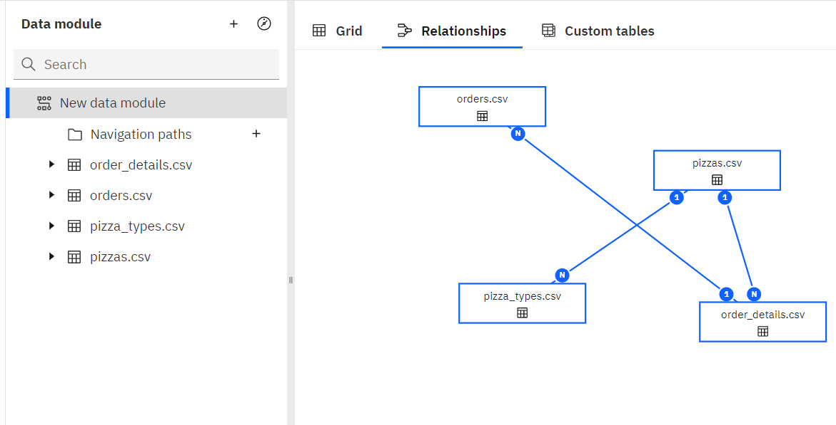

1. Create a custom table by selecting "Custom table" from the menu on the left-hand side of the screen.
2. Select the "order_detail" and "pizza.csv" tables.

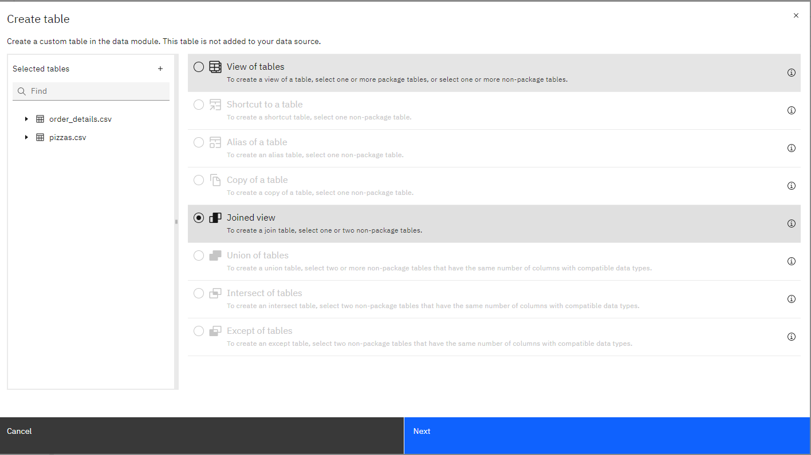

1. Define the join between the two tables by linking the "pizza_id" column in the "order_detail.csv" table with the "id" column in the "pizzas.csv" table.

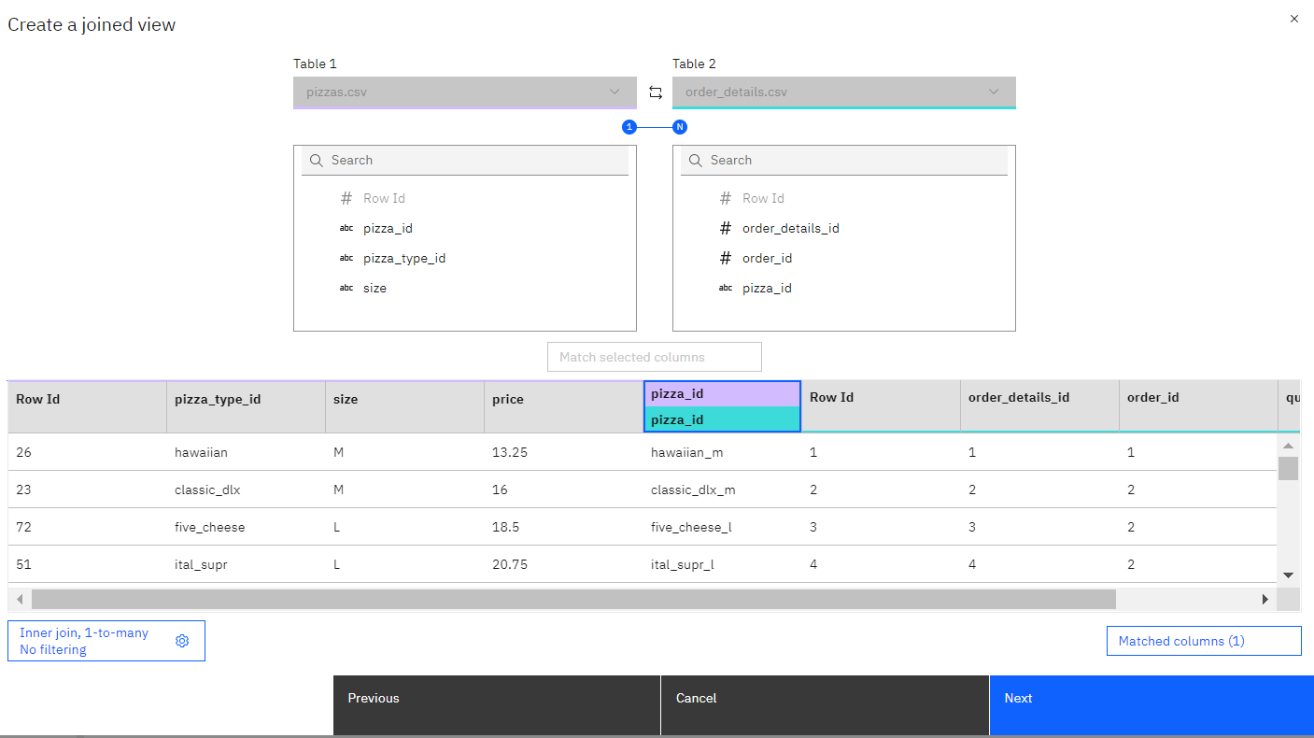

1. Name your custom table "Joined Table”.

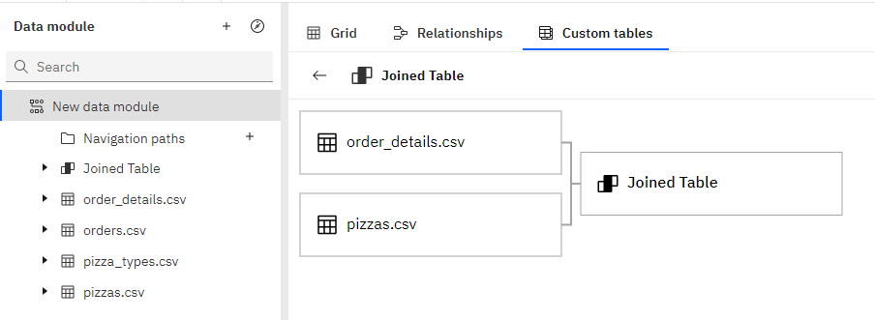

1. Add a calculation to the custom table by selecting the "Joined Table” next to "Calculations" on the clicking three dots in Joined Table of the screen.

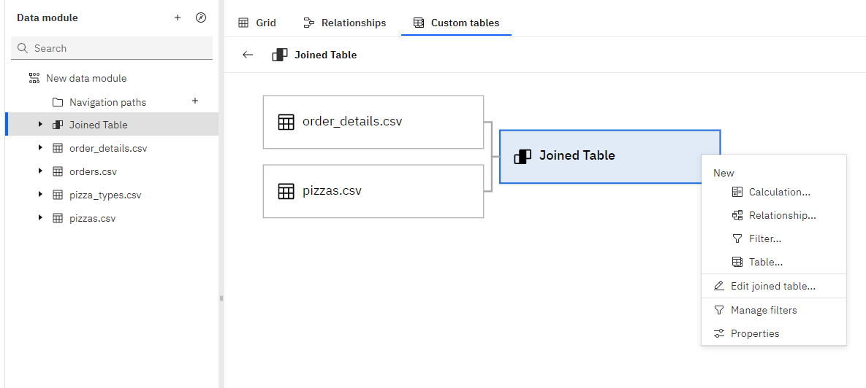

1. Name your calculation "Total Price" and define it as the product of the "price" and "quantity" columns

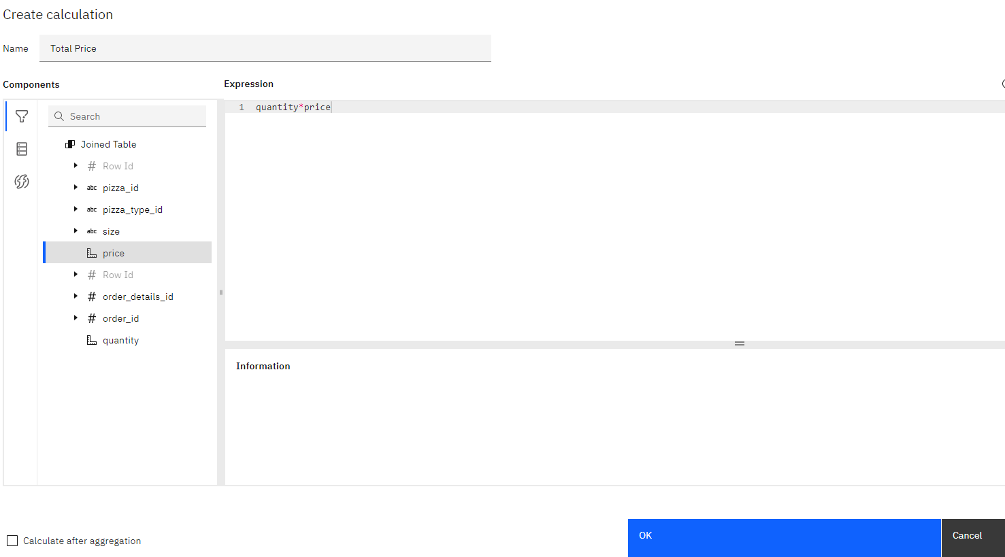

1. Save your custom table and return to the data module.
2. Define relationships between the “Joined Table”and “Order.csv” and “Joined Table” and “pizza_type.csv” in your dataset. 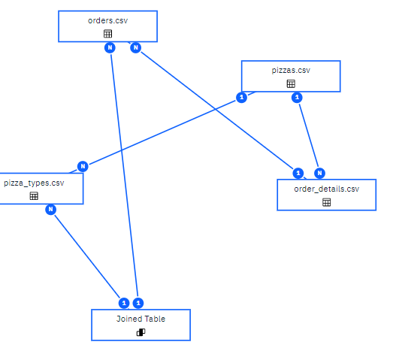
3. Define any additional relationships, calculations, or formatting that you wants to apply to your data in the data module.
4. Click "Save" to save your data module and give name “Pizza Dataset”.
5. Your data module is now ready to be used to create reports, dashboards, or other visualizations in IBM Cognos Analytics.

**Dashboard**

IBM Cognos Dashboard is a business intelligence tool that allows users to create custom dashboards and visualizations to analyze and present data from various sources. The tool is part of the IBM Cognos Analytics suite and provides users with an easy-to-use interface for designing and sharing dashboards with colleagues.

With IBM Cognos Dashboard, users can drag and drop different widgets and charts onto their dashboard, connect to multiple data sources, and configure various settings to create a customized view of their data. The tool supports a wide range of data visualization options, including tables, charts, maps, and gauges.

**Uses of Dashboard:**

Some common uses of dashboards in IBM Cognos:

1. **Monitor performance:** Dashboards allow users to monitor performance metrics in real-time, providing instant visibility into the health of the business. Users can track key performance indicators such as sales, revenue, customer satisfaction, and more.
2. **Analyze data:** Dashboards provide a visual representation of data, making it easier for users to analyze trends and patterns. Users can drill down into data to gain deeper insights and identify the root causes of issues.
3. **Make informed decisions**: Dashboards help users make informed decisions by providing timely and relevant information. Users can quickly identify trends, outliers, and areas that require attention, enabling them to make data-driven decisions.
4. **Improve collaboration:** Dashboards improve collaboration by providing a common view of data and metrics. Users can share dashboards with other team members, facilitating communication and collaboration.
5. **Increase productivity:** Dashboards increase productivity by providing a centralized location for data analysis. Users can access key metrics and data in one place, reducing the need to switch between multiple applications and reports.

Overall, dashboards in IBM Cognos are a powerful tool for data analysis and decision-making, providing users with real-time visibility into key business metrics.

**Steps to create a dashboard in IBM Cognos:**

The steps to create a dashboard in IBM Cognos:

1. Log in to IBM Cognos Analytics and go to the "Dashboard" menu on the left-hand side of the screen.
2. Click on "Create Dashboard" to start creating a new dashboard.
3. Give your dashboard a name and a description.
4. Choose a layout for your dashboard. You can choose from a variety of pre-built layouts or create your own custom layout.
5. Add content to your dashboard by clicking on the "Content" tab. You can add charts, tables, maps, and other visualizations to your dashboard.
6. Drag and drop the visualization components from the "Content" tab onto the canvas of your dashboard.
7. Configure each component by selecting the component and clicking on the "Properties" tab. You can set the data source, filters, and other options for each component.
8. Save your dashboard by clicking on the "Save" button.
9. Your dashboard is now ready to be used.

**Problems**

**Some of the Problems which were asked:**

1. What was the total revenue generated in 2015, organized by month and year?
2. Create a chart that displays the contribution of each category to total pizza sales.
3. Identify the weekday with the highest pizza sales during a particular hour.
4. Create a line chart that illustrates the fluctuation in total sales over the years.
5. Determine which pizza type was the most popular in the month of June.

**Interpretation of these queries are:**

1. **For showing the “Total Revenue” generated in 2015, organized by month and year we will simply use Crosstab tool.**

**STEP:**

* First open a Dashboard in an IBM Cognos and go to Visualization tab on left.
* Then select the **Crosstab Tool** and drag-drop.
* Select ‘Year’ in Columns field, ‘Month’ in Rows field and ‘Total Price’ in Values field from the Pizza Dataset.
* Then Result will be shown in this way.

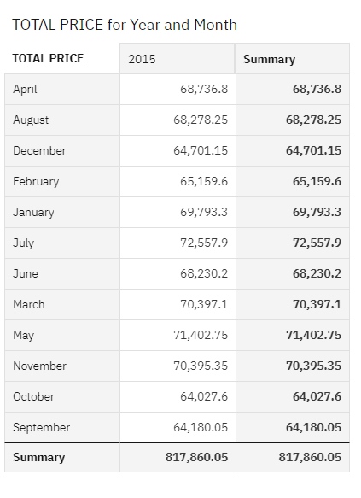

*From this data we get “Total Revenue” generated in 2015, organized by Month and Year.*

1. **For showing the contribution of each category to total pizza sales using chart.**

**STEP:**

* First open a Dashboard in an IBM Cognos and go to Visualization tab on left.
* Then select the **column tool** and drag-drop.
* We select ‘Category’ in Bars field, ‘Total Price’ in Length field and ‘Category’ in color field from the Pizza Dataset.
* Then Result will be shown in this way.

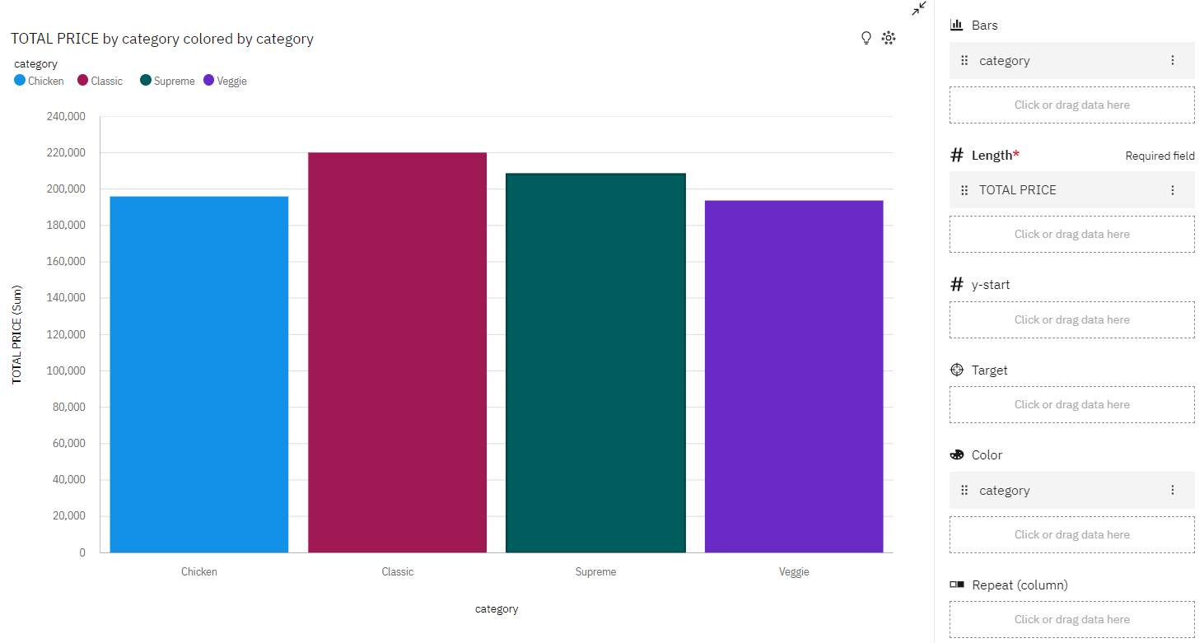

*From this data we get**the information about the contribution of each category of total pizza sales.*

1. **For showing the contribution weekday with the highest pizza sales during a particular hour.**

**STEP:**

* First open a Dashboard in an IBM Cognos and go to Visualization tab on left.
* Then select the **Column tool** and **Drop Down** and drag-drop.
* We select ‘Weekday Basis on Date’ in Bars field, ‘Total Price’ in Length field and ‘Weekday Basis on Date’ in color field from the Pizza Dataset.
* Select ‘Round of Time’ in Drop-Down Selection field from the Pizza Dataset.
* Then Result will be shown in this way.

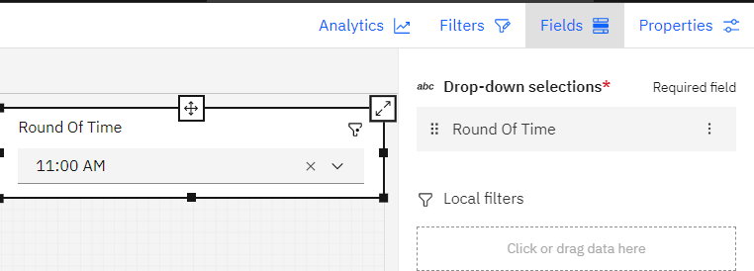

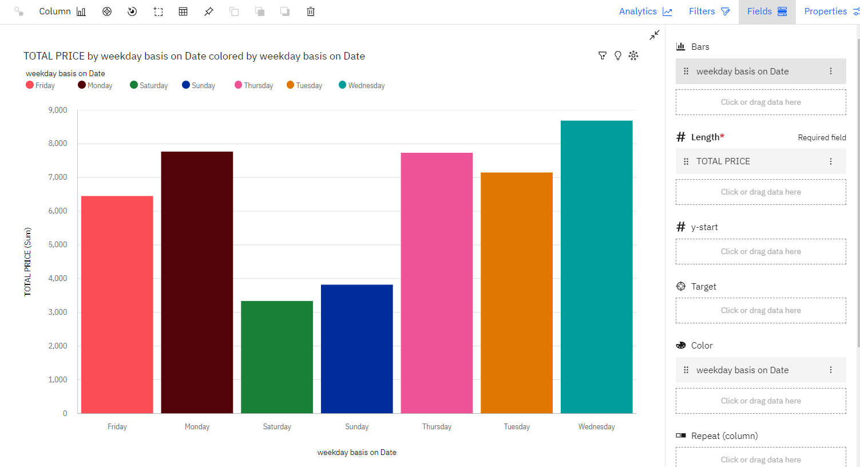

*From this data we identify the weekday**the highest pizza sales during a particular hour.*

1. **For showing a line chart that represent the total sales over the years.**

**STEP:**

* First open a Dashboard in an IBM Cognos and go to Visualization tab on left.
* Then select the **Line Chart** and drag-drop.
* We select ‘Year’ in X-axis field, ‘Total Price’ in Y-axis field from the Pizza Dataset.
* Then Result will be shown in this way.

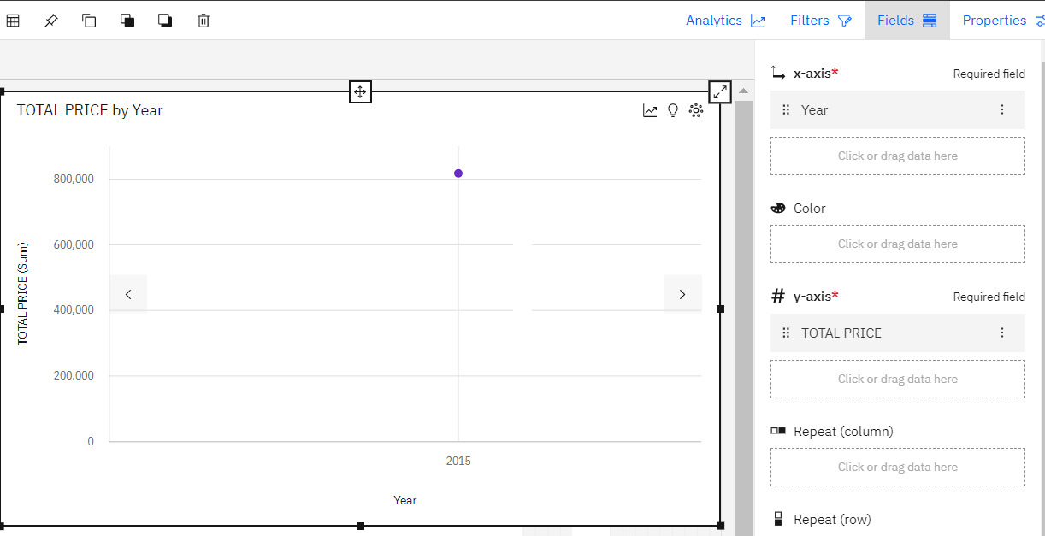

*From this data we get**the information about the total sales over the year.*

**5. For showing which pizza type was the most popular in the month of June.**

**STEP:**

* First open a Dashboard in an IBM Cognos and go to Visualization tab on left.
* Then select the **Drop Down, Pie Chart and Column Chart** and drag-drop.
* We select ‘Month’ column in Drop Down Selections field in Drop Down tool, ‘Category’ in Segments field, ‘Total Price’ in Size field in Pie Chart from the Pizza Dataset.
* Then Result will be shown in this way.

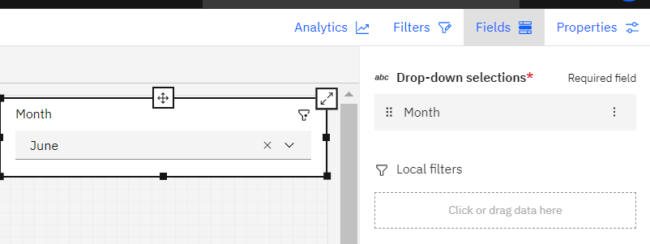

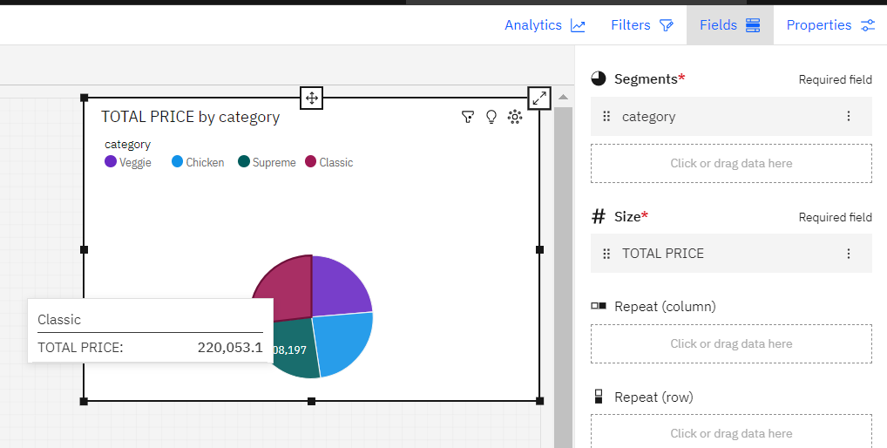

*From this data we get**the information about the most popular pizza type in the month of June. Here we see In the Pie Chart “Classic” pizza types are more sales which are most popular in month of June.*

**Conclusion**

The Pizza dataset module in IBM Cognos is likely a data source used to create dashboards related to pizza orders and sales. The module is likely connected to the various tables in the Pizza dataset, including the "order_detail", "order.csv", "pizza_type", and "pizzas.csv" tables.

Using this data, an IBM Cognos user could create a dashboard that visualizes key metrics related to pizza sales, such as total revenue, number of orders, and most popular pizza types.

They could also use the data to analyze customer behavior, such as identifying the busiest days of the week or the most common toppings ordered.

Overall, the Pizza dataset module in IBM Cognos is likely a valuable tool for analyzing and visualizing pizza order data, and could be used by businesses in the pizza industry to gain insights and make data-driven decisions.